

PROPOSAL TO RECLASSIFY AIRSPACE IN THE VICINITY OF HUMBERSIDE AIRPORT
FROM CLASS G TO CLASS D

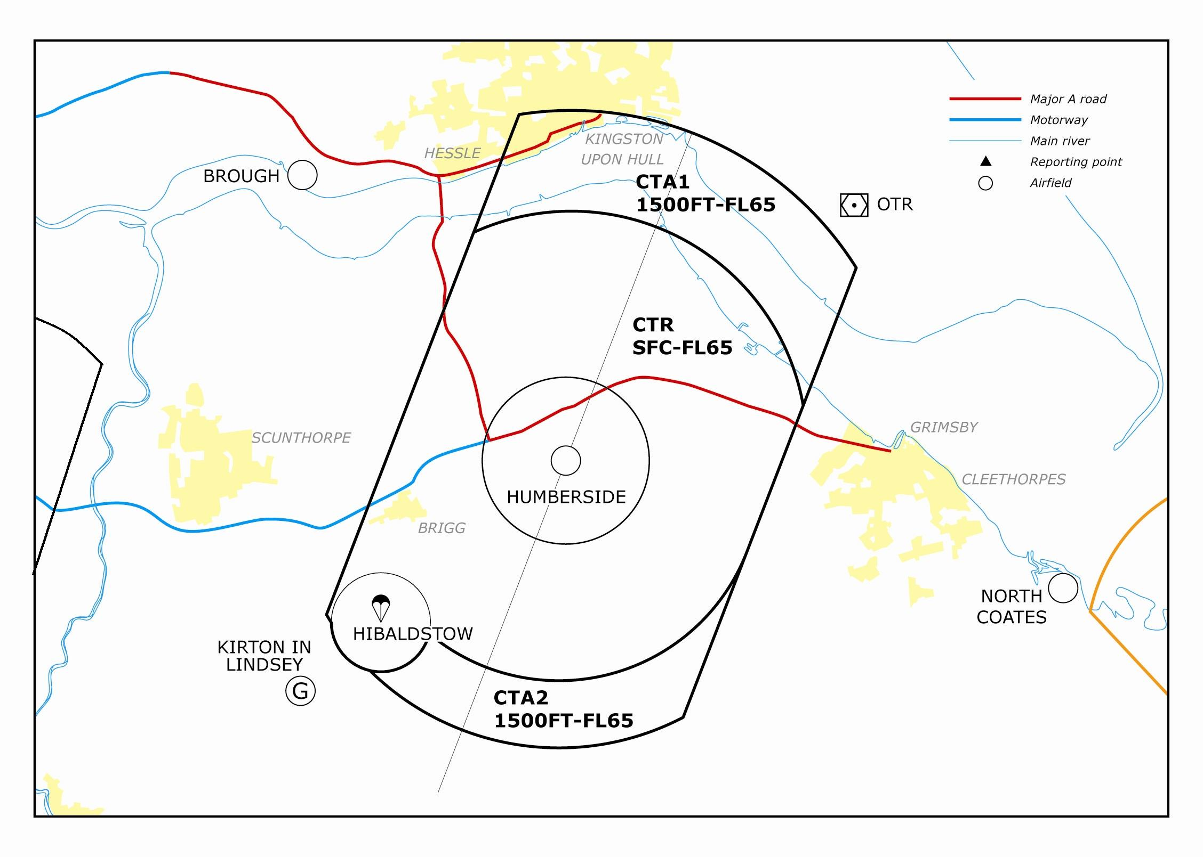

STAKEHOLDER CONSULTATION FEEDBACK
Executive Summary

On completion of the Stakeholder Consultation Phase of the Airspace Change Proposal (ACP), it is a requirement for the Change Sponsor, Humberside Airport, to provide feedback on the Stakeholder consultation exercise, setting out the main issues and key themes identified throughout the consultation. Stakeholders consulted included the MoD, which in this instance mainly represented the RAF stations in the region, and some 206 national and regional agencies, organisations and operators of local airfields. The overall response is summarised below.

This document summarises the key themes identified by Humberside Airport, and for simplicity, the issues are split into 2 groups, military and civilian. This report will be made available on the following website: www.humbersideairport.com, in the ‘About Us’ Section, under ‘Development’.

In the event that a representative organisation wishes to present new evidence or data to the Director, Airspace Policy, for his consideration prior to making his regulatory decision regarding a Change Sponsor proposal, the representative organisation must submit, in writing, the information to the following:
Director,
Directorate of Airspace Policy,
CAA House,
45-49 Kingsway,
London,
WC2B 6TE.

Humberside Airport will shortly compile the Formal Submission and send it to DAP for the next stage in the process, the Regulatory Decision by DAP. There are two main phases within this stage: the Proposal will be checked by the Regulator to confirm if all the specified documentation is included as part of the Proposal submission, and the second is the Regulator’s analysis of the technical merits behind the Proposal against the specified requirements. Finally, the Director, Airspace Policy makes the regulatory decision to approve or reject the ACP. If approved, it is hoped that the ACP will be promulgated within either AIRAC cycle 3 or 4 of 2010, dates to be confirmed.

NOTE : Stakeholders should be aware that due to the fluctuation of magnetic variation, it has been necessary in April 09 to redesignate the runways at Humberside from 21/03 to 20/02 (The secondary runway 09/27 has also been redesignated 08/26). There has been no physical change as a result of this redesignation, and it has not affected the ACP in any way.

TABLE OF CONTENTS

Page

- Introduction 4
- Military Issues 5
3. Civilian Issues 9
- Modified Design 10
- Summary 14
5. Abbreviations and Acronyms 15
6. Glossary 16

FEEDBACK ON HUMBERSIDE AIRPORT’S AIRSPACE CHANGE PROPOSAL FROM THE STAKEHOLDER CONSULTATION EXERCISE

Introduction

At the end of the Stakeholder Consultation Phase, Humberside Airport re-evaluated the merits of the design of the proposed Controlled Airspace (CAS) in light of the comments and observations received from various stakeholders. To do so, a balance had to be sought between satisfying the operational requirements of the airport, fulfilling the necessary design requirements, the needs of other airspace users, and the impact any changes would have. The changes that have been deemed necessary and appropriate are detailed later in this document.
For reference, the map of the original proposal is shown below, Figure 1. The main issues raised by stakeholders are then listed. The response by Humberside Airport to stakeholders concerns follows, leading to the explanation and justification for the modified design of the CAS.

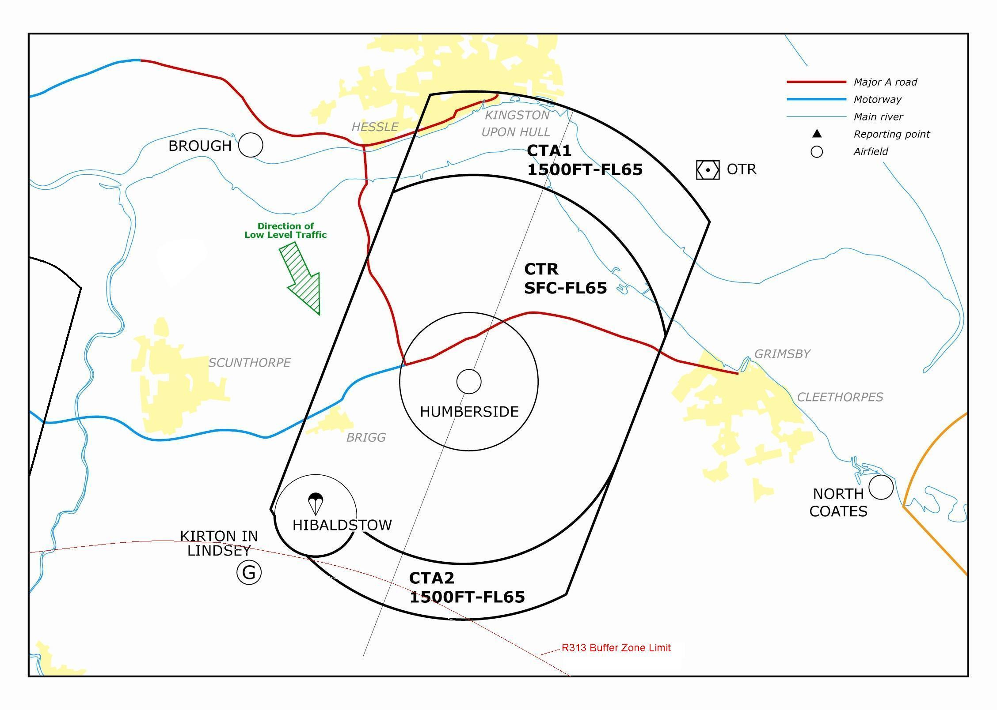
Figure 1: Original ACP Design
MILITARY ISSUES

- Flow Arrow and Low Level Access. The Military require a guarantee that aircraft will still able to continue to transit the area at low level (LL), following the flow arrow which routes to the west of Humberside Airport after the establishment of Class D airspace. Further, it was felt that the original upper limit within the shelf of 500ft Minimum Separation Distance (MSD) was insufficient for Elementary Flying Training School (EFTS) students in civil registered aircraft and assurance was required that such students would be able to transit at not above 1000ft Humberside QNH. As well as satisfying Rule 5 of the Rules of the Air, this would also provide a measurable upper limit, removing the subjective assessment of 500ft MSD from inexperienced aviators. Also, given the ability and experience levels of the EFTS students, i.e. they are unable to accept orbits or vectors for delay without possibly jeopardising the aim of the sortie, the Military require that basic solo students will have primacy when transitting the shelf. The ideal solution to the EFTS issues would be for the shelf to remain as Class G airspace, as basic students are not able to enter Class D airspace under current RAF regulations.

- Top Level of CAS. An explanation and justification for the top level was sought as it was felt that it was unnecessarily high and could cause problems for transitting FTS aircraft, particularly in icing conditions. The hold at Humberside is published at 2000ft QNH, and the provision of another aircraft in the hold at 3000ft plus an additional 1000ft buffer indicated to the military that 4000ft could be a viable top level.

- Radio Chatter. It has been noted that the VHF channel can be very busy, and sometimes precludes contact by military aircraft/makes in-cockpit instruction difficult due to the high level of background chatter.

- CTA2 Height. The height of CTA2 was queried with respect to fulfilling 500ft MSD when flying civilian registered aircraft under the area, and the terrain height to the south of the airport.

- Access to CAS. Assurance was sought that transit aircraft and training aircraft would still be able to access the proposed CAS.

- Infringement of R313 Buffer Zone. Due to the design of the proposed CAS, CTA2 infringes the ‘buffer zone’ of R313, the RAF Aerobatic Team’s practice area at RAF Scampton. The buffer zone extends 5nm beyond the limits of R313, and encompasses an area within which the establishment of CAS is not normally granted unless some form of agreement is reached whereby, under the flexible use of airspace, the units involved can still operate in the area safely. The area of overlap can be described as an almost horizontally aligned lens shape, which at its widest, extends to 7nm on the Final Approach Track (FAT) to RW02 (which equates to a maximum width of 1nm). See Figure 1.

Mitigation

- Flow Arrow and Low Level Access. Within the CAS design, a LL shelf was originally established with a top height of 500ft MSD. The original LL ‘shelf’ was adjusted to adequately encompass the area of the current flow arrow and the routes flown by the different aircraft types that used the UKLFS. To test the feasibility of the shelf, the airport and the RAF jointly conducted a 6-month trial from April to Sep 08, during which time RAF aircraft flew the shelf using the proposed boundaries, and Humberside Airport recorded the details of each flight. No problems were reported.
Observing primacy for solo EFTS students whilst in the shelf could be seen to be contravening 2 rules of the air – aircraft must give way to other aircraft making an approach to an airfield, and when 2 aircraft are converging at around the same altitude, the aircraft that has the other on it’s right must give way. It could be argued that this situation would occur if an EFTS aircraft was transitting the LL shelf at around 1000ft Humberside QNH and an aircraft was carrying out an IFR approach to RW02. Thus, the aircraft transitting the shelf area would have to give way. Furthermore, another factor to be considered is that training aircraft have a lower priority than IFR flights.
MATS Pt 1 Section 3 Chapter 4 Para 3.1 (Integration of VFR Flights with IFR Traffic in Class D CTR/CTA) states:

…Separation standards are not prescribed for application by ATC between VFR flights or between VFR and IFR flights in Class D airspace. However, ATC has a responsibility to prevent collisions between known flights and to maintain a safe, orderly and expeditious flow of traffic. This objective is met by passing sufficient traffic information and instructions to assist pilots to ‘see and avoid’ each other as specified at….

Humberside Airport recognises that the LL shelf is an unusual situation and thus one that requires more than just the passing of traffic information (TI) to satisfy our duty of care.
Furthermore, Humberside Airport is keen to minimise the disruption to other airspace users in the area caused by the establishment of CAS, and hopes to maintain the good working relationship with the military. Thus, the airport has decided to take the following steps to fulfil the requirements of the MATS Pt 1 whilst still allowing normal LL military operations.
Humberside Airport will introduce a step down fix at 4nm on the Final Approach Track (FAT) to RW02, at 1620ft Humberside QNH, which is the height that an aircraft should be at on the nominal 3.5 degree glidepath. The boundary of the shelf at this point is around 4.25nm on the FAT. The terrain in the area of the 4nm FAT point varies between 12-17m (approximately 40 – 55ft), thus the majority of LL traffic will have 1000ft vertical separation should both aircraft converge around the 4nm point. Given the frequency of usage of RW02, which is around 25% of the time, this event is anticipated to be a rare occurrence, evident by the lack of such during the aforementioned 6-month trial of the shelf. EFTS aircraft at not above 1000ft Humberside QNH will have less than 1000ft separation, but more than 500ft separation. The details of the LL shelf operation will be promulgated in both the Civil and Military AIPs, and as TI will be passed as a matter of course, Humberside Airport considers that this more than satisfies the necessary requirements.

The airport chose Class D airspace as this fulfils the aim of creating a known traffic environment in the vicinity of the airport and also allows access by both IFR and VFR traffic. Leaving the shelf as Class G would nullify the whole point of the ACP, notwithstanding the fact that it could funnel GA traffic into an area regularly used by LL military traffic. The issue regarding EFTS students being unable to enter Class D airspace is therefore regarded as one that requires addressing by the RAF. It is believed that the RAF is in the process of reviewing the relevant orders.

- Top Level of CAS. Even though the hold is published as 2000ft in the Terminal Approach Charts (TAPs), it must be noted that this is the minimum hold level. To allow for normal day-to-day operations, the hold operates at 3000ft QNH. This allows for any non-standard manoeuvring in the visual circuit above 1000ft, as well as uninterrupted offshore helicopter operations requiring 2000ft for transit. Other airports with a similar minimum published hold altitude also normally operate holds at 3000ft or above. The top level of FL65 was chosen as it allows for operation in a non-radar environment. In such an environment, aircraft operations are constrained by a safety altitude of 2700ft, based on the Belmont TV Mast to the SE of the airport. Thus, aircraft could only safely be released to fly at 3000ft or above. In such circumstances, it would be necessary to have the minimum hold level of 4000ft. Given that procedural operations are recognised as very slow, it is likely that it could be necessary to hold other aircraft, which would necessitate the use of 5000ft in the overhead. However, it was considered that such a situation would be extremely rare, and Humberside Airport re-examined the top level requirement in light of the military’s comments. Although Cat C and D commercial aircraft rarely fly the full procedure, preferring to route as direct as possible, the hold and procedures are regularly used for training purposes by smaller aircraft (Cat A and B), and frequently BE20s from RAF Cranwell. The usual profile would be for the aircraft to establish in the hold at FL50, until ready to execute the approach. This allows for continued uninterrupted VFR and helicopter departures, and IFR departures up to FL40, which, subject to the direction and distance flown, may only be a technical stop off in the climb. This is considered to be the most expeditious method of fulfilling the airport’s operational requirements, as well as those of the training aircraft. To continue this effective practice, and taking into account stakeholders comments, it was considered that a top level of 6000ft on the Humberside QNH would be sufficient, rather than FL65.
The concern regarding EFTS aircraft experiencing icing conditions around or above the top level of CAS is a legitimate one, though hopefully a rare occurrence. Moreover, EFTS aircraft transiting through the area would in all likelihood be in R/T contact with Humberside, and thus could expect a clearance through CAS at a suitable level.

- Radio Chatter. The installation of a UHF channel should allow easier contact by military aircraft and the frequency should be quiet enough to allow training aircraft to monitor during instruction.

- CTA2 Height. Examination of the terrain under CTA2 to find the highest obstacle revealed a spot height based on a trig point to the north of the Claxby Radar site of 168m amsl (546ft). From TAP charts, there is a spot height of 551ft to the south east of the airport, and other obstacles to the south east, based on the Caistor masts and Claxby site – 588ft/657ft– requires confirmation, but possibly highest obstacles within the CTZ. Thus, using 500ft MSD, civil registered EFTS aircraft would still be able to transit under CTA2, with a base height of 1500ft Humberside QNH. However, should it be necessary, it is anticipated that clearance for civilian registered military training aircraft to enter CTA2 will be automatically granted providing there is no conflicting traffic on the final approach segment to RW02, and previous experience would indicate that this would be a rare occurrence.

- Access to CAS. Once CAS is established, there will be no change to current policy regarding acceptance of training aircraft, and transit aircraft will only be required to change routing or level if a confliction is apparent – which is the situation as now, in Class G airspace. As there is no anticipated sudden dramatic increase in traffic levels post CAS establishment, access to/transit of zone will be granted.

- Infringement of R313 Buffer Zone. As per the Directorate of Airspace Policy’s directive regarding buffer zone infringement by CAS, steps to mitigate the issue will be taken. This will comprise a Letter Of Agreement (LOA) between the respective units to detail operating arrangements within the overlapping airspace. This will mainly comprise of the passing of information – Humberside will inform Waddington when using RW02, and Waddington will inform Humberside of the activation and deactivation of R313. Humberside will also pass traffic information to Waddington about traffic carrying out an instrument approach to RW02 when R313 is active and await clearance from OC RAFAT/relevant nominee to continue the approach. Historically, there have been no problems between Humberside Airport’s relatively infrequent RW02 approaches (RW02 used only 25% of the time) and RAFAT operations that have taken place in Class G airspace, so it is anticipated that there should be no problems in Class D airspace.

CIVILIAN ISSUES

  - The overall dimensions of the proposed CAS were queried, with several stakeholders requiring clarification of the justification for the design.

  - A number of General Aviation (GA) pilots expressed concern about the funnelling effect that could be created by the combination of the western boundary of Humberside’s ACP and the eastern boundary of Doncaster’s established CAS, which could, in their opinion, increase the hazard to GA aircraft in the area.

  - The passenger numbers at Humberside do not justify the establishment of CAS. Further, recent economic events are likely to lead to a continued downturn in passenger numbers (at least in the short term).

  - GA pilots expressed concerns over the loss of Class G airspace, especially since the establishment of CAS at Doncaster.

  - GA pilots expressed concerns over refusal of entry to the proposed area, citing examples of previous occasions when an airport had been granted CAS and then denied access to GA traffic.

  - Local stakeholders Doncaster, Hibaldstow (Target Skysports) and Trent Valley Gliding Club (TVGC), at Kirton in Lindsey, require LOAs to formalise procedures once CAS is established to ensure that their operations continue with minimum disruption.

Mitigation

- Any design of CAS has to satisfy several ICAO criteria and CAA requirements. The proposed CAS has to ensure standard separation between all aircraft manoeuvring on departure and arrival lanes and holding patterns, together with associated joining manoeuvres for the hold. This effectively dictates the dimensions of the proposed CAS, although as the proposed CAS is not connected to the on-route structure, there are no set departure lanes to consider, only holding, arrival and IFR procedures. These dimensions are then refined according to local requirements, and then, where necessary, simplified so as to be easily plotted on aeronautical charts. The original design was based on a scoping study carried out some years ago, based on the extant regulations, and of minimum airspace necessary to contain the aforementioned operations.
The regulations have since changed with regards to the protection afforded to IFR aircraft carrying out published procedures, and the design had to be adjusted to meet the criteria, which is explained in greater detail in the next section.

- The majority of aircraft operating in South Yorkshire and North Lincolnshire are aware of the variance and intensity of aircraft operations in the area, and thus will request some form of service from the appropriate unit, usually Basic Service (BS) if VFR. Most of the aircraft operating in the area between Humberside and Doncaster will be in contact with one of the units. Military aircraft will, in future, be mandated to call Humberside to transit the LL shelf. Aircraft will only be funnelled between the 2 units if they do not establish contact with either unit to request transit through CAS. In the majority of cases, it is anticipated that aircraft will be granted clearance through CAS, subject to other traffic, in the same way as they do now. If the intensity of traffic is a concern with regards to the ‘see and avoid’ principle, there is always the option available to request an upgrade in the type of service to Traffic Service (TS).
However, bearing in mind stakeholders comments, re-examination of the design of CAS following the Consultation exercise indicated that it would be possible to adjust the western boundary of CAS 1nm eastwards. Humberside’s IFR procedures would still be fully contained and adequately protected within this area, and Humberside Airport acceded to stakeholders concerns by adjusting the design accordingly. Thus any funnelling effect should to an extent, be alleviated.

- The main aim of the ACP is to enhance Flight Safety in the immediate vicinity of the airport. The establishment of CAS will create a known traffic environment within which this aim will be attained. Passenger numbers, historically the driving force behind the establishment of CAS, are currently only one factor in the decision making process. Humberside airport has diverse operations – offshore helicopters and flying schools as well as scheduled and chartered operations and the airport has a loyal customer base, which enjoys the relatively straight forward, and hassle free environment at the airport. Also, the airport has not experienced the low cost airline boom-and-bust type scenarios experienced at other airports. The Airport is pragmatically looking to the long-term future and therefore cannot be overly influenced by recent events. Thus, the ACP is still considered to be an important part in the future strategy of the Airport.

- Whereas the loss of Class G airspace is unavoidable, Class D airspace does not preclude VFR flight. It must be stressed that the purpose of the ACP is to establish a known traffic environment, which will enhance flight safety for all concerned, and not to prevent GA flying within the area. Currently, the majority of aircraft operating in the area will be in contact with the Airport, and, even though they will be under a Basic Service (BS), with no mandate to comply with ATC instructions, pilots will normally comply with requests to temporarily change altitude or routing to deconflict with other traffic. The Airport does not anticipate that this situation will change in the future should Class D airspace be granted.

- The airport is forecasting a steady growth in passenger numbers, and not a sudden influx of aircraft that would be associated with establishing new routes for new carriers. Any manoeuvres requested of GA aircraft will, as is the case now, only be subject to other conflicting traffic. The airport has the resources and infrastructure to guarantee access to and through the area, should it be established. Manning is similar to other airports, with 2 radar controllers available to man 2 radar positions during normal working hours, which will ensure that aircraft requiring access to Class D airspace will be granted entry. This situation will be monitored after the establishment of CAS, and a log maintained detailing the circumstances of any refusal of entry to CAS.

- LOAs are being drafted and are subject to the agreement of the units concerned.

Modified Design

It is a ICAO Doc 8168 requirement that aircraft carrying out an IFR procedure are provided with safeguarding in the area around the nominal track that they would be expected to fly following a published procedure, which is especially relevant in a non-radar environment. The procedures plotted on the map below, Figure 2, show that the proposed CAS, whilst containing the nominal tracks, does not cover what is known as the ‘primary area’ – the area within which aircraft could actually fly following a the published procedure, but taking into account variables such as wind, and instrument error, among others.

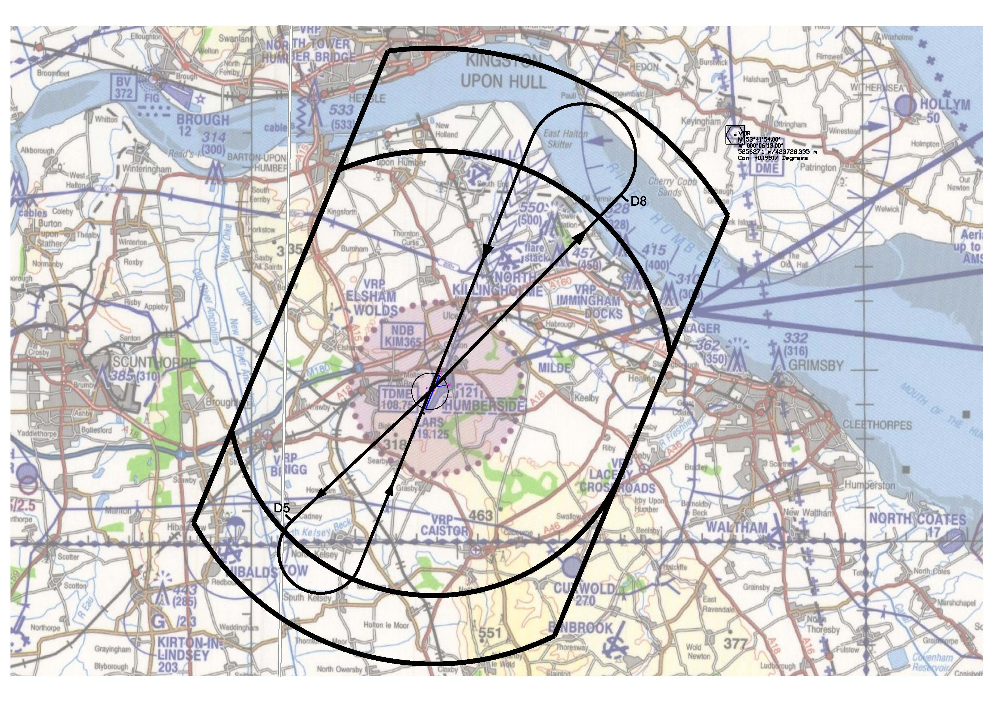
Figure 2: Humberside CAS and Nominal Tracks for IFR Procedures to RW20 and 02

The nominal track profile for RW20 in Figure 2 depicts the NDB to ILS procedure (Non-Directional Beacon to Instrument Landing System), currently flown at 2000ft. The radius of turn illustrated is for larger aircraft, classed as Category (Cat) C and D, (for example, aircraft such as Boeing 737 and Boeing 757s which are regular users of Humberside) and extends to some 9.5nm from the airport. Full safeguarding for this procedure would necessitate extending the northern part of CTA1 to around 12nm. This would not directly affect any unit’s operations, and it would not affect the aircraft’s normal operating profile. The normal profile for a Cat C/D aircraft would be to be radar vectored by Humberside ATC to intercept the ILS localiser around 8nm, which would involve positioning along the north bank of the River Humber from predominantly either the east or west, before being turned inbound towards the airfield. Thus, the modified area would not normally be utilised by CAT C/D aircraft, any more than is the case now.
It is recognised that the OTR beacon is an important navigation facility for traffic flying along the east coast, and it is possible to leave this outside the limits of the modified CAS, whilst still fulfilling safeguarding requirements, by adjusting the eastern boundary to track approximately 355° from the point at which it crosses the north bank of the Humber, to a point where it intercepts the 12nm radius arc depicting the new northern boundary of CTA1.
Following a DAP review of Humberside’s procedures, it will prove necessary to raise the height at which the NDB/DME procedure for RW20 is flown, (similar to the profile in Figure 2) from 1700ft to 2000ft. This satisfies the requirement for aircraft to be 500ft from the base of CAS, in this case, CTA1. This will lessen the noise impact slightly in the local area, so this can be viewed as a positive measure in environmental terms.
As previously mentioned, examination of the primary area around the nominal tracks for the IFR approaches to Humberside Airport revealed that it was possible to move the western boundary eastward by 1nm, which should help to alleviate the funnelling effect between Humberside and Doncaster. The western boundary does not then coincide with Hibaldstow’s zone boundary, and the issue of not including Hibaldstow’s zone within the CTR was considered, which would have decreased the funnelling effect further, albeit slightly. However, this would only be of benefit if Hibaldstow was not active, and it was felt that during the planning stages of a flight, pilots would not plan to overfly such a site as it is regularly used. The benefit was considered of minimal value, given the small area involved, outweighed by the added protection afforded to the operations at Hibaldstow, which is highly desirable by the operators.
The previous considerations have thus led to a modification of the original design, at Figure 3:

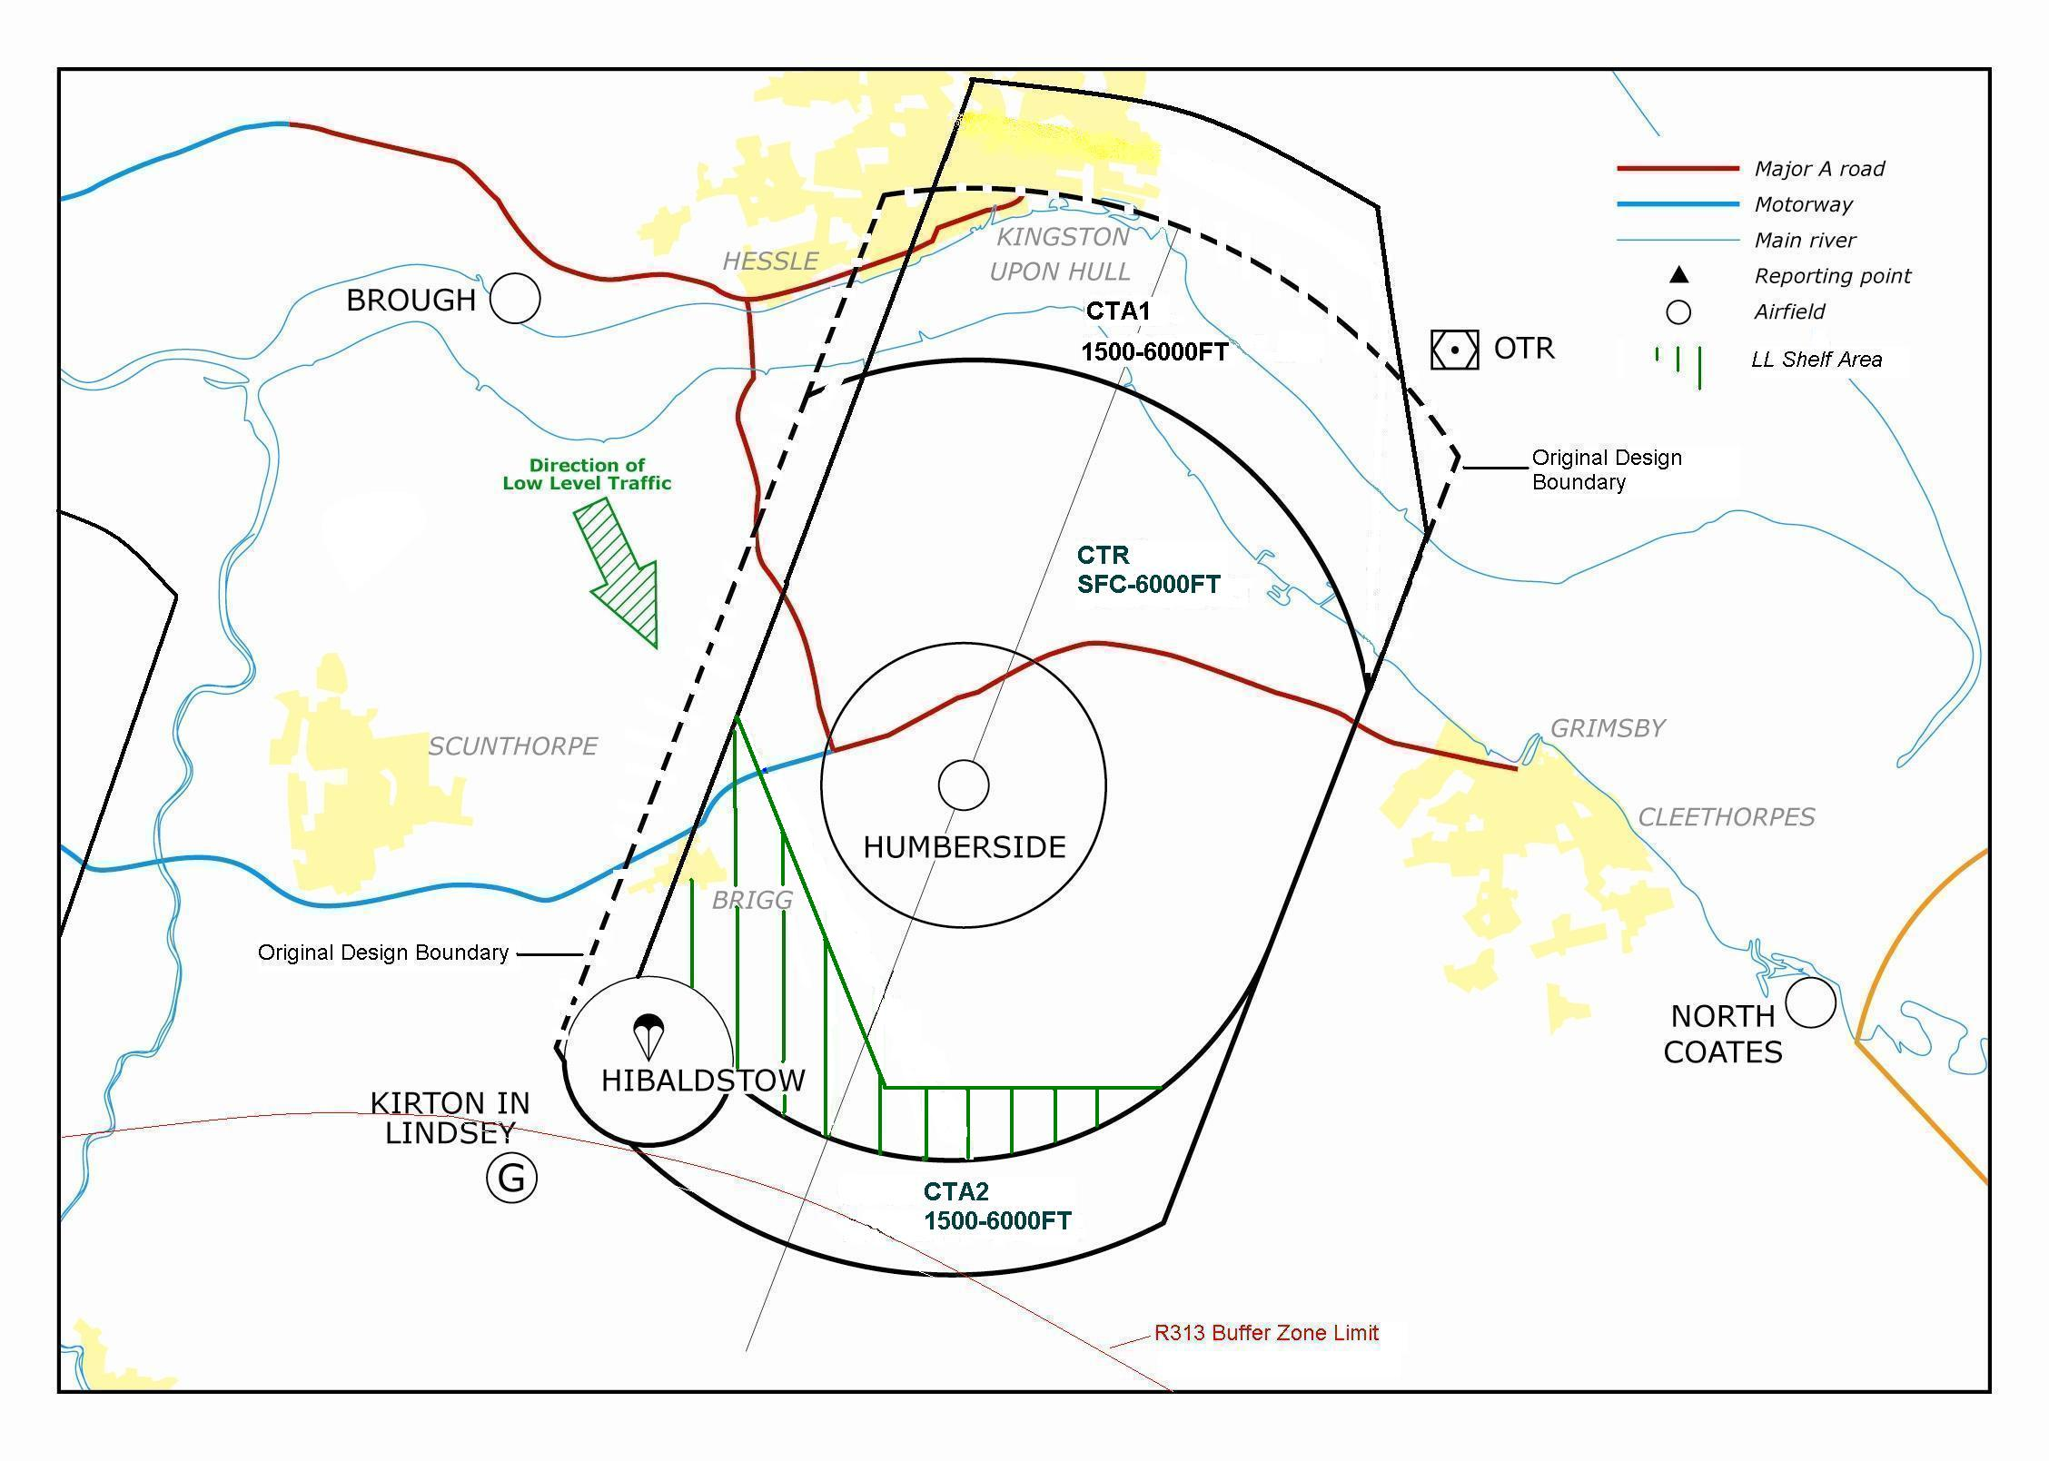
Figure 3: Modified ACP Design

The procedures to RW02 are of lesser dimensions than those to RW20, as RW02 has a 3.5° glidepath rather than a 3° glidepath, which means the aircraft commence their descent later, closer to the airfield, with a greater angle of descent. The CAS to the south encompasses the most frequently used procedure for RW02, which satisfies Humberside Airport’s operational requirement, whilst observing the different airspace activities that take place in and around the current proposed CAS boundary.
The current boundary was designed, as previously mentioned, with other airspace users in mind, notably TVGC, based at Kirton in Lindsey, and the RAFAT. A LOA is being drafted with TVGC to allow access to CTA2 in certain conditions, but it is felt that any further expansion of CTA2 would seriously impinge on their routine activities in the vicinity of their airfield as well.
The current boundary also infringes the R313 buffer zone, and while another LOA is being drafted to manage this situation, an increase in CAS would probably necessitate more restrictive measures. The new boundary that would satisfy all IFR procedure buffer zone requirements would be within 2.5nm of R313, which is occasionally not large enough to contain certain manoeuvres, as witnessed by RAFAT aircraft straying outside the area.
Additionally, should their be a requirement to move the southern boundary, a choke point would be created between the southern boundary of CTA2 and R313. Humberside Airport considers that this would be unacceptable to stakeholders, given the objections raised by the funnelling effect caused by the combined Class D areas of Doncaster and Humberside Airports.
Furthermore, given the excellent serviceability record of Humberside’s radar (see Table 1, indicating 31.5hrs downtime from over 32 000hours operation, or 0.097% of the operating time over nearly a 5 year period), it is close to 100% certain that any IFR approach on RW02 that could not be contained within the proposed airspace would also be radar monitored to ensure the safety of the IFR aircraft.

Date | Fault | Solution | Downtime
13/05/03 | Watchman Radar SPR Rack PSU fault | Replaced PSU | 1 hour
20/05/03 | Watchman Radar Main Beam/Obs light trip | Removed excessive grease | 30 mins
08/10/03 | Watchman Radar SPR SMPSU | Replaced PSU | 24hrs
02/01/04 | Watchman Radar RF Auxbeam heater fault | Replaced heater | 1 hr
28/01/04 | Watchman Radar TR Cell | Replace TR Cell | 50 mins
04/04/07 | Watchman Radar SPR DC supplies PSU | Loose plug | 4 hrs

Table 1. Humberside Airport Radar Serviceability

Taking into account the factors above, together with the fact that operations on RW02 occur only 25% of the time, Humberside Airport considered that other airspace users operational requirements were greater, and that the proposed CTA2 boundary did not merit expansion.
Summary

The modified design now proposed comprises of a CTR with 2 associated CTAs, 20nm long, 12nm to the north and 8nm to the south, with a width of 10nm, biased 4nm to the west and 6nm to the east, from the surface within the CTR, and from 1500ft within the CTAs to 6000ft Humberside QNH. The northeast sector comprises of a line drawn from where the eastern boundary of CTA1 crosses the north bank of the River Humber on an approximate bearing of 355° to the intercept of the 12nm radius arc of the northern boundary of CTA1. A ’shelf’ has been embedded in the CTR for use by military aircraft in the UKLFS up to 1000ft Humberside QNH, to maintain the integrity of the current flow arrow. To the southwest the CTR boundary encompasses the Hibaldstow paradropping zone, with an operating radius of 2nm. Overall, in comparison to the original design, the volume of airspace has been reduced.
Throughout the design and consultation phases of the ACP, Humberside Airport has sought to attain a balance between the operational requirements of the airport and of those of other airspace users, whilst complying with as many of the design requirements as possible as laid down in ICAO Doc 8168, MATS Pt1 and CAP 725. This has meant several adjustments to the original design, and the drafting of new agreements with other local airfields and agencies. The extension to the north of CTA1 does not immediately impact on any other airspace users operations nor increase the environmental impact on the population of Hull as the area will not be used by Humberside ATC for vectoring purposes any more than is the case at present. Any extension to the south to fully safeguard aircraft on an IFR approach to RW02, however, does directly affect other stakeholders and would create a narrow choke point for aircraft wishing to transit between Humberside’s CAS and R313. Taking into account the operational requirement for the use of RW02, which is considerably less than that for RW20 – 25%/75% split respectively - together with the excellent serviceability record of the unit’s radar, which allows for radar monitoring of approaches, it was felt that the unit could guarantee the safety of aircraft on a RW02 IFR procedure. Thus, in order to strike what we consider to be the correct balance between our requirements and those of other airspace users, as well as forestalling the likely objections that would be raised from other stakeholders, Humberside Airport considers the current proposed southern boundary sufficient for the task.
As stated previously, the expansion of CAS to the north does not immediately impact any other airspace users’ operations, thus, Humberside Airport considers the modifications to be neither significant enough nor to cause sufficient adverse affect to warrant a full consultation exercise. However, Humberside Airport does not want to be seen to be making arbitrary decisions where our stakeholders are involved, and will provide a 4-week period within which those Stakeholders in the immediate vicinity of the proposed change will be able to comment on the modified design. Those Stakeholders that fall within this category will receive details through the post or be contacted directly by the Project Officer.
Humberside Airport would like to take this opportunity to thank those Stakeholders who responded to the Consultation Document, or otherwise expressed an interest in the ACP process.

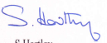
S Hartley
Air Traffic Control Manager
Humberside Airport

ABBREVIATIONS AND ACRONYMS

ACC Airport Consultative Committee
ACP Airspace Change Process
AMSL Above Mean Sea Level
ATC Air Traffic Control
ATCO Air Traffic Control Officer
ATZ Air Traffic Zone
BS Basic Service
CAA Civil Aviation Authority
CAP Civil Aviation Publication
CAS Controlled Airspace
CTA Control Area
CTR Control Zone
DAP Directorate of Airspace Policy (Division of the CAA)
FAT Final Approach Track
GA General Aviation
IAP Instrument Approach Procedure
ICAO International Civil Aviation Organisation
IFR Instrument Flight Rules
LoA Letter of Agreement
MOC Minimum Obstacle Clearance
MoD Ministry of Defence
MSD Minimum Separation Distance
MUACT Military Users Airspace Co-ordination Team
NATS National Air Traffic Services
NDB Non-Directional Beacon
nm Nautical Mile
PSR Primary Surveillance Radar
SID Standard Instrument Departure
SSR Secondary Surveillance Radar
TI Traffic Information
TS Traffic Service
UK LFS United Kingdom Low Flying System (Military)
VFR Visual Flight Rules
VRP Visual Reference Point
VOR Very High Frequency Omni Range

GLOSSARY OF TERMS

ATS Air Traffic Service. A generic term meaning variously, flight information service, alerting service, air traffic advisory service, air traffic control service (area control service, approach control
service or aerodrome control service).

ATZ Aerodrome Traffic Zone. The airspace in the vicinity of an aerodrome, the size of which is dependent on the length of the runway. For runways less than 1850 metres the airspace extends from the surface to a height of 2000ft above the level of the aerodrome within the area bounded by a circle centred on the notified mid-point of the longest runway and having a radius
of 2 nautical miles. Where the runway is more than 1850 metres e.g. as at HUY, the radius is 2 1/2 miles.

BS Basic Service. A Basic Service is an ATS provide for the purpose of giving advice and information useful for the safe and efficient conduct of flights. This may include weather information, changes of serviceability of facilities, conditions at aerodromes, general airspace activity information, and any other information likely to affect safety. The avoidance of other traffic is solely the pilot’s responsibility.

CAA Civil Aviation Authority. It is the duty of the CAA to develop, promulgate, monitor and enforce a policy for the sustainable use of UK airspace and for the provision of necessary supporting infrastructure for air navigation.

CAS Controlled Airspace. Refers to airspace in which traffic levels are such that it has been determined that air traffic control(ATC) must provide some form of separation between aircraft.
The airspace is of defined, and published, dimensions.
Class A. Airspace Airways, except where they pass through a TMA or CTR of a lower status. Aircraft flying under visual flight rules are not allowed in this airspace. Separation is provided to all aircraft flying in this airspace.
Class B Airspace This class is not currently allocated in the UK
Class C Airspace Except for 2 isolated segments this airspace is only used above FL 195 in the UK.
Class D Airspace Mostly CTRs and CTAs that permit IFR and VFR flight in accordance with specified conditions. The most common class of CAS established around airports within the UK.
Class E Airspace Allocated to segments of the Scottish TMA, Belfast TMA and Durham Tees Valley Control Zone. It is similar to Class D but with a reduced traffic information from ATC and no ATC clearance is required.
Class F Airspace This is for advisory routes along which a civil air traffic advisory service is available to participating aircraft.
Class G Airspace Aircraft are able to fly without any flight plan or air traffic clearance in accordance with specified flight rules. This is the most common class of airspace outside CAS and advisory
airspace in the UK.

CTA. Control Area. A controlled airspace extending upwards from a specified limit above the earth to a specified upper limit. CTAs can be further classified as:
(i) Airway A control area, or part thereof, in the form of a corridor, equipped with radio navigation aids.
(ii) Terminal Control Area (TMA) A control area, normally established at the confluence of airways, in the vicinity of one or more major aerodromes.

CTR/CTR Control Zone. An area of controlled airspace extending upwards from the surface of the earth to a specified upper limit.

dBA dBA is used to denote the levels of noise measured on an weighted decibel scale (i.e. a frequency weighting that is applied to the electrical signal within a noise measuring instrument as a
way of simulating the way the human ear responds to a range of acoustic frequencies).

DAP Directorate of Airspace Policy. The airspace approval and regulatory authority that conducts the planning of airspace and related arrangements in the UK. It ensures that the UK
airspace is utilized in a safe and efficient manner. This is achieved through the developments, approvals and enforcement of policies for the effective allocation and use of UK airspace and its supporting infrastructure taking into account the needs of all stakeholders.

DME Distance Measuring Equipment. A combination of ground and airborne equipment which gives a continuous slant range distance-from-station readout by measuring time-lapse of a signal transmitted by the aircraft to the station and responded back. DME can also provide groundspeed and time-to-station readouts by differentiation.

DS Deconfliction Service. A radar service whereby pilots will be passed the position of conflicting traffic, followed by advice to maintain separation. Exceptionally, at controllers’ discretion, separation advice will be given first, followed by the position of the conflicting traffic.

FAT Final Approach Track. Between 4 and 12 nms of straight flight descending at a set rate (usually an angle of between 2.5 and 6 degrees) following the magnetic track of the designated runway prior to landing.

FL Flight Level. A surface of constant atmospheric pressure, which is related to a specific pressure datum (1013.2mb, also known as the standard pressure setting, or SPS) and is
separated from other such surfaces by specific pressure intervals. FLs roughly equate to thousands of feet, thus FL170 is around 17,000ft. All aircraft above a certain altitude fly on the
SPS, which then guarantees vertical separation between aircraft.

GA General Aviation. All flights other than military and scheduled flights, both private and commercial.

HEIGHT Height. The vertical distance of a level, a point or object considered as a point measured from a specified datum.

IFR Instrument Flight Rules. To be obeyed by pilots when it is not possible for an aircraft to be flown in Visual Meteorological Conditions or at night, or when operating in airspace in which
IFR must be adhered to in all meteorological conditions.

LARS Lower Airspace Radar Service. Its primary objective is to aid the flow of air traffic arriving at, and departing from, those airfields by encouraging aircraft transiting the area to receive an
air traffic service (ATS). This reduces the amount of avoiding action for all aircraft and also enhances the efficient use of that airspace by providing a known traffic environment. However,
it’s use by transiting aircraft is not mandatory.

MSD Minimum Separation Distance. The distance that must be maintained between any part of an aircraft in flight and the ground, water or any object.

NATS National Air Traffic Services provides air traffic control services at 15 of the UK's biggest airports, and "en-route" air traffic services for aircraft flying through UK airspace and the eastern part of the North Atlantic.

NDB Non-Directional Beacon. A medium frequency navigational aid which transmits non-directional signals, superimposed with a Morse Code identifier and received by an aircraft’s automatic direction finder.

PSR Primary Surveillance Radar. The PSR transmits a beam of RF (Radio Frequency) energy in a given direction through 360° as the radar antenna rotates. This beam is narrow in azimuth
and wide in elevation. The RF energy is reflected by objects within the beam and these objects are referred to as targets. Some of the reflected energy is collected by the antenna and routed to the radar receiver that will then process the received signals and produce a target report containing the range and azimuth position of the target. If digital processing is used, then the heading and velocity of the target can also be calculated. Data is sent to a radar display system that produces a Plan Position Indicator (PPI) map that is then displayed on a monitor for the use of the ATC controller.

Reporting Points Reporting Points. Navigational points within a piece of CAS (normally part of an airway).

TS Traffic Service. This service provides only traffic information i.e. bearing, distance and if available the level of conflicting traffic. No avoiding action will be offered and pilots
are wholly responsible for maintaining separation from other traffic whether or not controllers have passed traffic information.

STAR Standard Arrival Route. A designated IFR arrival route linking a significant point, normally on an ATS route, with a point from which a published instrument approach procedure can be
commenced.

SSR Secondary Surveillance Radar. SSR differs from PSR in that it transmits a coded interrogation as a series of pulses to a responder fitted to the aircraft. When the transponder receives the message it responds with a coded reply, the content of which is dependant on the type of interrogation. The coded reply can be one of several parameters. The azimuth of the radar
scanner at the time of the reply and the time delay between interrogation and reply derive the azimuth and range of the aircraft relative to the radar. In addition, the interrogation can be
used to ascertain the barometric height of an aircraft. SSR is an active system and only displays returns on a PPI from suitably equipped aircraft and thus is immune to the clutter arising from
passive reflective objects that affect PSR.

SVFR Special Visual Flight Rules. A flight made at any time in a control zone which is Class A airspace, or in any other control zone in IMC or at night, in respect of which the appropriate air
traffic control unit has given permission for the flight to be made in accordance with special instructions given by that unit instead of in accordance with the Instrument Flight Rules and in the
course of which flight the aircraft complies with any instructions given by that unit and remains clear of cloud and in sight of the surface.

VOR Very High Frequency Omni-Directional (Radio) Range. A radio navigation aid operating in the 108-118 MHz band. A VOR ground station transmits a 2-phase directional signal through
360 degrees. The aircraft’s VOR receiver enables a pilot to identify his radial or bearing from/to the ground station.

VFR Visual Flight Rules. Meteorological conditions expressed in terms of visibility, horizontal and vertical distance equal to or better than a specified minima.

VRP Visual Reference Point. A prominent natural or man-made feature which will be readily identifiable from the air established in the vicinity of an aerodrome located within CAS in order to
facilitate access to and from aerodromes located within, and transit of, CAS by VFR traffic. They may also be used to assist pilots to plan routes around CAS when traffic conditions require.

